|  |
| --- |
|  |
| National University of Computer & Emerging Sciences |
|  |

|  |  |
| --- | --- |
| Course Instructor | Sara Rehmat |
| Lab Instructor | Asad Khan |
| Semester | Fall 2019 |

Lab Manual

Introduction to Information

&

Communication Technologies



# Lab # 03: Introduction to Microsoft Office Excel 2007

**Objective:**

Contents

Lab # 03: Introduction to Microsoft Office Excel 2007 1

* Getting Started Microsoft Excel 2007 3
  + Spreadsheets 4
  + Microsoft Office Button 4
  + Ribbon 4
  + Quick Access Toolbar 5
  + Mini Toolbar 6
* Working with Workbook 7
  + Create a Workbook 7
  + Save a Workbook 8
  + Opena Workbook 10
  + Entering Data 11
* Manipulating Data 12
  + Select Data 12
  + Select a Row or Column 12
  + Copy and Paste 12
  + Cut and Paste 13
  + Undo and Redo 13
  + Auto Fill 14
* Modifying a Worksheet 15
* Performing Calculations 17
* Sort and Filter 20
* Graphics 23
* Charts 27
* Formatting a Worksheet 30
* Developing a Workbook 37
* Page Properties and Printing 41
* Layout 45
* Customize Excel 47
  + Popular 47
  + Formulas 48
  + Proofing 49
  + Save 50
  + Advanced 51
  + Customize 52

**Instructions:**

* You are allowed to use your own laptops.
* You can consult the books, manuals and class lectures.
* You should have stationary like register and ballpoint to analyze the tasks first.
* Ensure that you working environment is working properly.
* Only in practice session, consultation is allowed.
* Attempt all questions yourself.
* No discussion is allowed during tasks solution.
* Submission of all tasks’ solutions is necessary in any way.
* Tasks completed in specified time will be graded.
* Cheating is strictly prohibited otherwise rules as per university will be applied as a result of F-Grade in lab.
* This lab manual referenced from



## Getting Started Microsoft Excel 2007

Getting started with Excel 2007 you will notice that there are many similar features to previous versions.  You will also notice that there are many new features that you’ll be able to utilize.  There are three features that you should remember as you work within Excel 2007:  the Microsoft Office Button, the Quick Access Toolbar, and the Ribbon.  The function of these features will be more fully explored below.

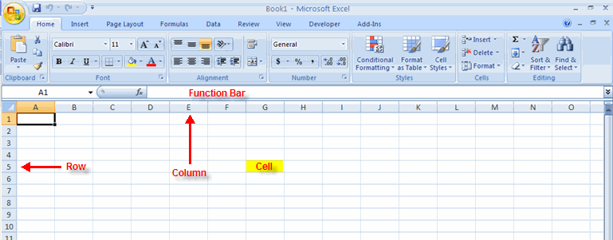

### Spreadsheets

A spreadsheet is an electronic document that stores various types of data.  There are vertical columns and horizontal rows.  A cell is where the column and row intersect.  A cell can contain data and can be used in calculations of data within the spreadsheet.  An Excel spreadsheet can contain workbooks and worksheets.  The workbook is the holder for related worksheets.

### Microsoft Office Button

The Microsoft Office Button performs many of the functions that were located in the File menu of older versions of Excel.  This button allows you to create a new workbook, Open an existing workbook, save and save as, print, send, or close.

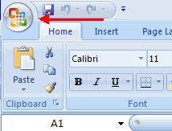

### Ribbon

The ribbon is the panel at the top portion of the document. It has seven tabs:  Home, Insert, Page Layouts, Formulas, Data, Review, and View.  Each tab is divided into groups.  The groups are logical collections of features designed to perform function that you will utilize in developing or editing your Excel spreadsheets.

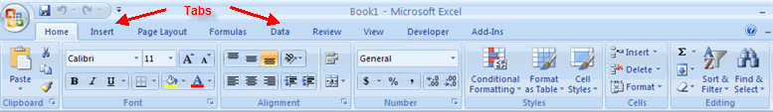

Commonly utilized features are displayed on the Ribbon.  To view additional features within each group, click the arrow at the bottom right corner of each group.

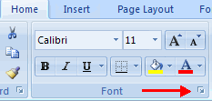

**Home**:  Clipboard, Fonts, Alignment, Number, Styles, Cells, Editing  
**Insert**: Tables, Illustrations, Charts, Links, Text  
**Page Layouts**: Themes, Page Setup, Scale to Fit, Sheet Options, Arrange  
**Formulas**: Function Library, Defined Names, Formula Auditing, Calculation  
**Data**:  Get External Data, Connections, Sort & Filter, Data Tools, Outline  
**Review**:  Proofing, Comments, Changes  
**View**: Workbook Views, Show/Hide, Zoom, Window, Macros

### Quick Access Toolbar

The **quick access toolbar** is a customizable toolbar that contains commands that you may want to use.  You can place the quick access toolbar above or below the ribbon.  To change the location of the quick access toolbar, click on the arrow at the end of the toolbar and click **Show Below the Ribbon**.

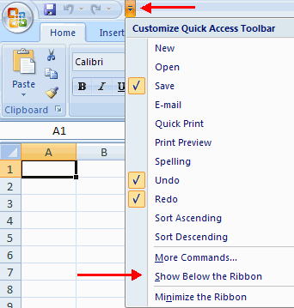

You can also add items to the quick access toolbar.  Right click on any item in the Office Button or the Ribbon and click Add to Quick Access Toolbar and a shortcut will be added.

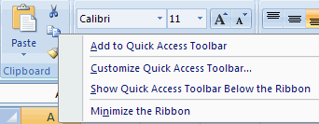

### Mini Toolbar

A new feature in Office 2007 is the Mini Toolbar.  This is a floating toolbar that is displayed when you select text or right-click text.  It displays common formatting tools, such as Bold, Italics, Fonts, Font Size and Font Color.

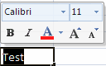

## Working with Workbook

### Create a Workbook

To create a new Workbook:

* Click the **Microsoft Office Toolbar**
* Click **New**
* Choose **Blank Document**

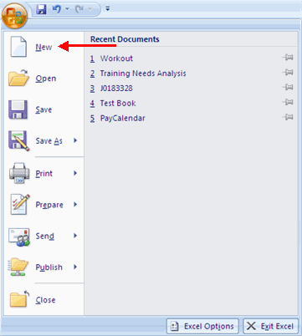

If you want to create a new document from a template, explore the templates and choose one that fits your needs.

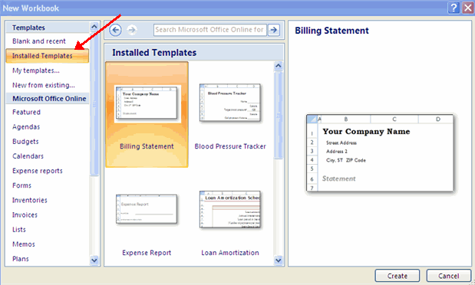

### Save a Workbook

When you save a workbook, you have two choices: **Save** or **Save As**.  
To save a document:

* Click the **Microsoft Office Button**
* Click **Save**

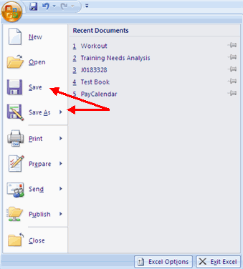

You may need to use the **Save As** feature when you need to save a workbook under a different name or to save it for earlier versions of Excel.  Remember that older versions of Excel will not be able to open an Excel 2007 worksheet unless you save it as an Excel 97-2003 Format. To use the **Save As** feature:

* Click the **Microsoft Office Button**
* Click **Save As**
* Type in the name for the Workbook
* In the **Save as Type** box, choose **Excel 97-2003 Workbook**

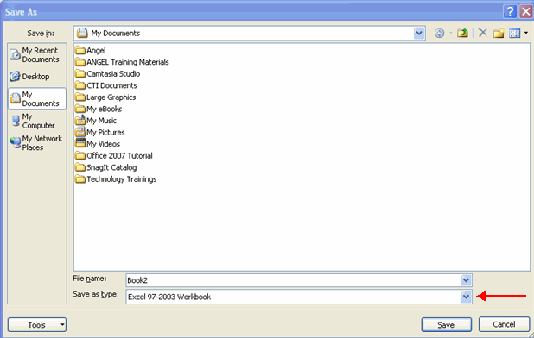

### Open a Workbook

To open an existing workbook:

* Click the **Microsoft Office Button**
* Click **Open**
* Browse to the workbook
* Click the title of the workbook
* Click **Open**

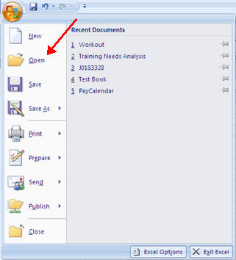

### Entering Data

There are different ways to enter data in Excel:  in an active cell or in the formula bar.  
To enter data in an active cell:

* Click in the **cell**where you want the data
* Begin typing

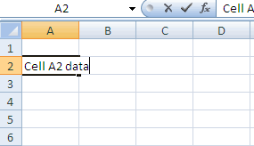

To enter data into the **formula bar**

* Click the cell where you would like the data
* Place the cursor in the **Formula Bar**
* Type in the data

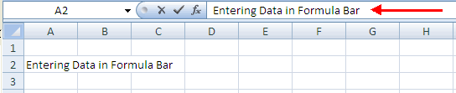

## Manipulating Data

Excel allows you to move, copy, and paste cells and cell content through cutting and pasting and copying and pasting.

### Select Data

To select a cell or data to be copied or cut:

* Click the **cell**

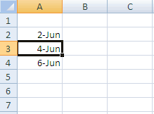

* Click and drag the cursor to select many cells in a range

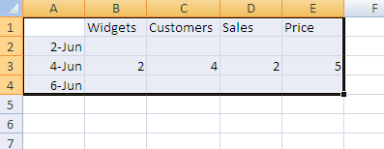

### Select a Row or Column

To select a row or column click on the **row** or **column header**.

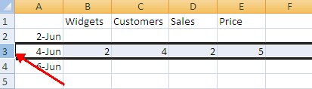

### Copy and Paste

To copy and paste data:

* Select the cell(s) that you wish to copy
* On the **Clipboard**group of the **Home**tab, click **Copy**

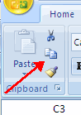

* Select the cell(s) where you would like to copy the data
* On the **Clipboard**group of the **Home** tab, click **Paste**

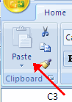

### Cut and Paste

To cut and paste data:

* Select the cell(s) that you wish to copy
* On the **Clipboard**group of the **Home**tab, click **Cut**

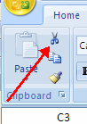

* Select the cell(s) where you would like to copy the data
* On the **Clipboard**group of the **Home**tab, click **Paste**

### Undo and Redo

To undo or redo you’re most recent actions:

* On the **Quick Access Toolbar**
* Click **Undo** or **Redo**

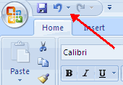

### Auto Fill

The Auto Fill feature fills cell data or series of data in a worksheet into a selected range of cells. If you want the same data copied into the other cells, you only need to complete one cell.  If you want to have a series of data (for example, days of the week) fill in the first two cells in the series and then use the auto fill feature. To use the Auto Fill feature:

* **Click**the **Fill Handle**
* **Drag**the **Fill Handle** to complete the cells

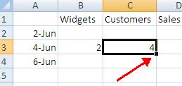

## Modifying a Worksheet

**Insert Cells, Rows, and Columns**

To insert cells, rows, and columns in Excel:

* Place the cursor in the row below where you want the new row, or in the column to the right of where you want the new column
* Click the **Insert**button on the **Cells**group of the **Home**tab
* Click the appropriate choice: **Cell, Row,  or Column**

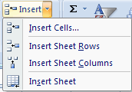

**Delete Cells, Rows and Columns**

To delete cells, rows, and columns:

* Place the cursor in the cell, row, or column that you want to delete
* Click the **Delete**button on the **Cells**group of the **Home** tab
* Click the appropriate choice:  **Cell, Row, or Column**

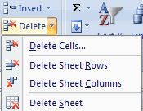

**Find and Replace**  
To find data or find and replace data:

* Click the **Find & Select**button on the **Editing**group of the **Home**tab
* Choose **Find** or **Replace**
* Complete the **Find What** text box
* Click on **Options** for more search options

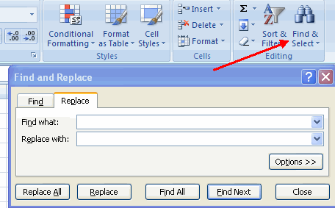

**Go To Command**  
The Go to command takes you to a specific cell either by cell reference (the Column Letter and the Row Number) or cell name.

* Click the **Find & Select**button on the **Editing**group of the **Home**tab
* Click **Go To**

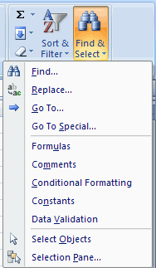

**Spell Check**  
to check the spelling:

* On the **Review**tab click the **Spelling**button

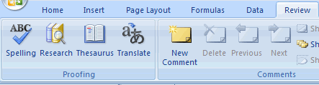

## Performing Calculations

**Excel Formulas**

A formula is a set of mathematical instructions that can be used in Excel to perform calculations.  Formals are started in the formula box with an = sign.

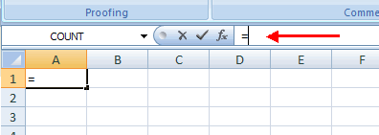

There are many elements to and excel formula.

**References:**  The cell or range of cells that you want to use in your calculation  
**Operators**:  Symbols (+, -, *, /, etc.) that specify the calculation to be performed  
**Constants**:  Numbers or text values that do not change  
**Functions**:  Predefined formulas in Excel

To create a basic formula in Excel:

* Select the **cell** for the formula
* Type **=**(the equal sign) and the**formula**
* Click **Enter**

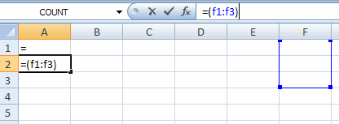

**Calculate with Functions**  
A function is a built in formula in Excel.  A function has a name and arguments (the mathematical function) in parentheses.  Common functions in Excel:

**Sum**:  Adds all cells in the argument  
**Average**:  Calculates the average of the cells in the argument  
**Min**:  Finds the minimum value   
**Max**:  Finds the maximum value  
**Count**:  Finds the number of cells that contain a numerical value within a range of the argument

To calculate a function:

* Click the **cell** where you want the function applied
* Click the **Insert Function**button
* Choose the function
* Click **OK**

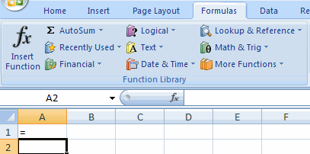

* Complete the Number 1 box with the first cell in the range that you want calculated
* Complete the Number 2 box with the last cell in the range that you want calculated

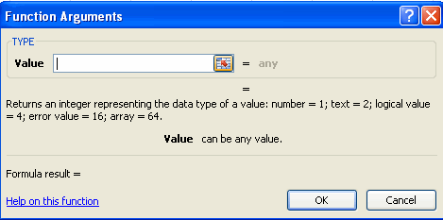

**Function Library**  
The function library is a large group of functions on the Formula Tab of the Ribbon.  These functions include:

**AutoSum**:  Easily calculates the sum of a range  
**Recently Used**:  All recently used functions  
**Financial**: Accrued interest, cash flow return rates and additional financial functions  
**Logical**: And, If, True, False, etc.  
**Text**: Text based functions  
**Date & Time**: Functions calculated on date and time  
**Math & Trig**:  Mathematical Functions

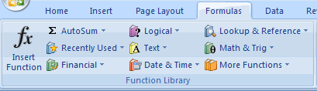

**Relative, Absolute and Mixed References**

Calling cells by just their column and row labels (such as "A1") is called **relative referencing**. When a formula contains relative referencing and it is copied from one cell to another, Excel does not create an exact copy of the formula. It will change cell addresses relative to the row and column they are moved to. For example, if a simple addition formula in cell C1 "=(A1+B1)" is copied to cell C2, the formula would change to "=(A2+B2)" to reflect the new row. To prevent this change, cells must be called by **absolute referencing** and this is accomplished by placing dollar signs "**$**" within the cell addresses in the formula. Continuing the previous example, the formula in cell C1 would read "=($A$1+$B$1)" if the value of cell C2 should be the sum of cells A1 and B1. Both the column and row of both cells are absolute and will not change when copied. **Mixed referencing** can also be used where only the row OR column fixed. For example, in the formula "=(A$1+$B2)", the row of cell A1 is fixed and the column of cell B2 is fixed.

**Linking Worksheets**  
You may want to use the value from a cell in another worksheet within the same workbook in a formula. For example, the value of cell A1 in the current worksheet and cell A2 in the second worksheet can be added using the format "sheetname!celladdress". The formula for this example would be "=A1+Sheet2!A2" where the value of cell A1 in the current worksheet is added to the value of cell A2 in the worksheet named "Sheet2".

## Sort and Filter

Sorting and Filtering allow you to manipulate data in a worksheet based on given set of criteria.

**Basic Sorts**  
To execute a basic descending or ascending sort based on one column:

* Highlight the cells that will be sorted
* Click the **Sort & Filter** button on the **Home** tab
* Click the **Sort Ascending** (A-Z) button or **Sort Descending** (Z-A) button

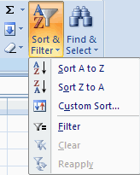

**Custom Sorts**  
To sort on the basis of more than one column:

* Click the **Sort & Filter** button on the **Home** tab
* Choose which column you want to sort by first
* Click **Add Level**
* Choose the next column you want to sort
* Click **OK**

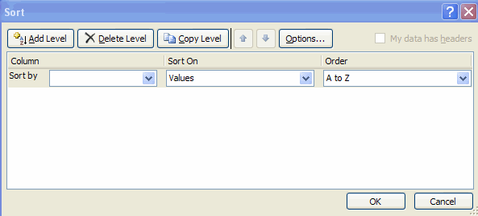

**Filtering**  
Filtering allows you to display only data that meets certain criteria. To filter:

* Click the column or columns that contain the data you wish to filter
* On the **Home** tab, click on **Sort & Filter**
* Click  **Filter** button
* Click the **Arrow** at the bottom of the first cell
* Click the **Text Filter**
* Click the **Words** you wish to Filter

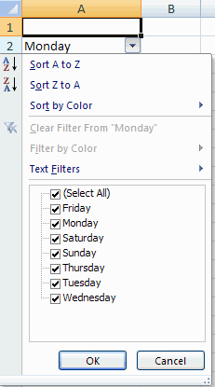

* To clear the filter click the **Sort & Filter** button
* Click **Clear**

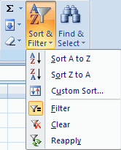

## Graphics

**Adding a Picture**  
To add a picture:

* Click the **Insert** tab
* Click the **Picture** button
* Browse to the picture from your files
* Click the **name** of the picture
* Click **Insert**
* To move the graphic, click it and drag it to where you want it

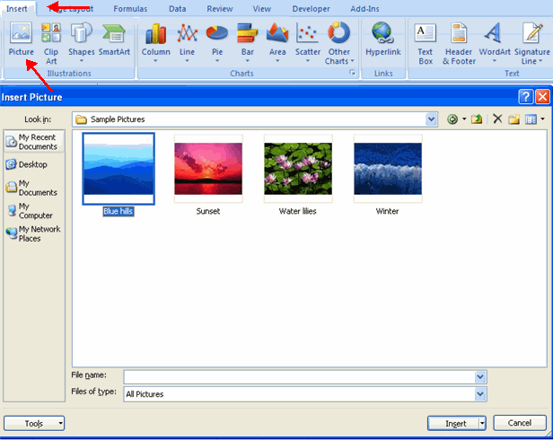

**Adding Clip Art**  
To add Clip Art:

* Click the **Insert** tab
* Click the **Clip Art** button
* Search for the clip art using the search **Clip Art** dialog box
* Click the **clip art**
* To move the graphic, click it and drag it to where you want it

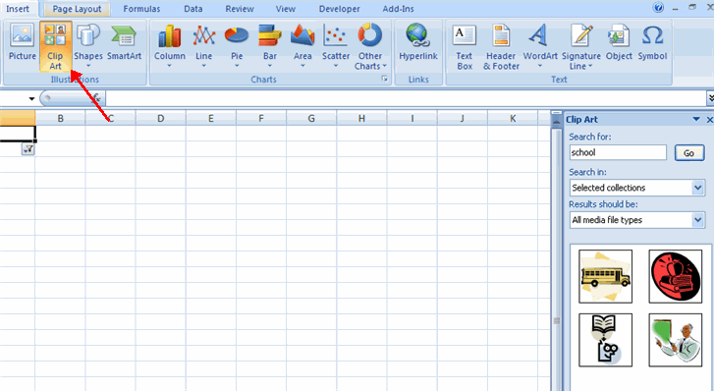

**Editing Pictures and Clip Art**  
When you add a graphic to the worksheet, an additional tab appears on the Ribbon.  The Format tab allows you to format the pictures and graphics.  This tab has four groups:

**Adjust**:  Controls the picture brightness, contrast, and colors  
**Picture Style**:  Allows you to place a frame or border around the picture and add effects  
**Arrange**:  Controls the alignment and rotation of the picture  
**Size**:  Cropping and size of graphic

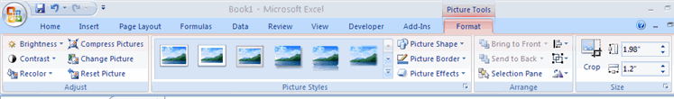

**Adding Shapes**  
To add Shape:

* Click the **Insert** tab
* Click the **Shapes** button
* Click the shape you choose

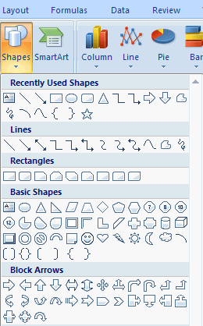

* Click the **Worksheet**
* Drag the cursor to expand the Shape

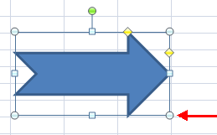

To format the shapes:

* Click the **Shape**
* Click the **Format** tab

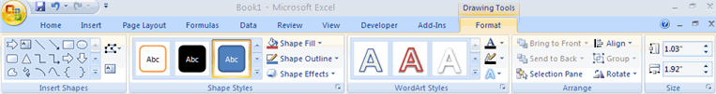

**Adding SmartArt**  
SmartArt is a feature in Office 2007 that allows you to choose from a variety of graphics, including flow charts, lists, cycles, and processes.  To add SmartArt:

* Click the **Insert** tab
* Click the **SmartArt** button
* Click the **SmartArt** you choose

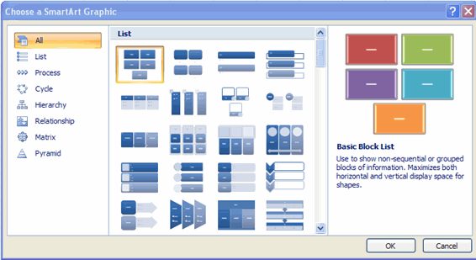

* Select the **Smart Art**
* Drag it to the desired location in the worksheet

To format the SmartArt:

* Select the **SmartArt**
* Click either the **Design** or the**Format** tab
* Click the **SmartArt** to add text and pictures.

## Charts

Charts allow you to present information contained in the worksheet in a graphic format. Excel offers many types of charts including: Column, Line, Pie, Bar, Area, Scatter and more.  To view the charts available click the Insert Tab on the Ribbon.

**Create a Chart**  
To create a chart:

* Select the **cells** that contain the data you want to use in the chart
* Click the **Insert** tab on the Ribbon
* Click the type of **Chart** you want to create

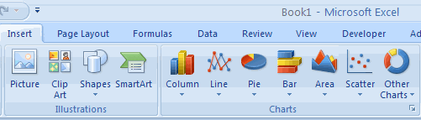

**Modify a Chart**  
Once you have created a chart you can do several things to modify the chart.

To move the chart:

* Click the **Chart** and **Drag** it another location on the same worksheet, or
* Click the **Move Chart** button on the **Design** tab
* Choose the desired location (either a new sheet or a current sheet in the workbook)

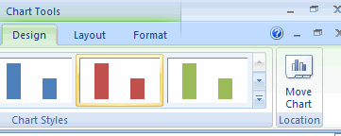

To change the data included in the chart:

* Click the **Chart**
* Click the **Select Data** button on the **Design** tab

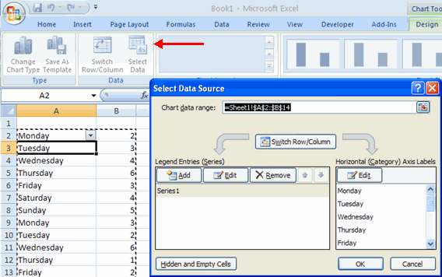

To reverse which data are displayed in the rows and columns:

* Click the **Chart**
* Click the **Switch Row/Column** button on the **Design** tab

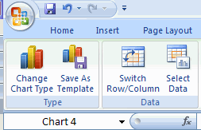

To modify the labels and titles:

* Click the **Chart**
* On the **Layout** tab, click the **Chart Title** or the **Data Labels** button
* Change the **Title** and click **Enter**

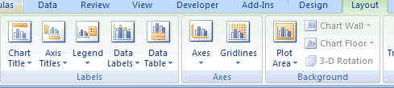

**Chart Tools**The Chart Tools appear on the Ribbon when you click on the chart.  The tools are located on three tabs:  Design, Layout, and Format.    
  
Within the **Design** tab you can control the chart type, layout, styles, and location.

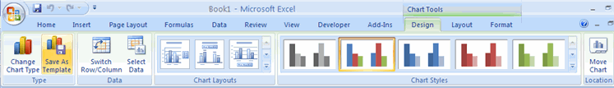

Within the **Layout** tab you can control inserting pictures, shapes and text boxes, labels, axes, background, and analysis.

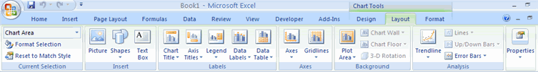

Within the **Format** tab you can modify shape styles, word styles and size of the chart.

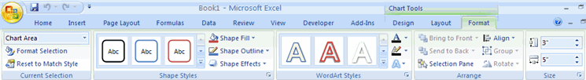

**Copy a Chart to Word**

* Select the **chart**
* Click **Copy** on the **Home** tab
* Go to the **Word** document where you want the chart located
* Click **Paste** on the **Home** tab

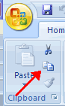

## Formatting a Worksheet

**Convert Text to Columns**  
Sometimes you will want to split data in one cell into two or more cells.  You can do this easily by utilizing the Convert Text to Columns Wizard.

* Highlight the column in which you wish to split the data
* Click the **Text to Columns** button on the **Data** tab
* Click **Delimited** if you have a comma or tab separating the data, or click fixed widths to set the data separation at a specific size.

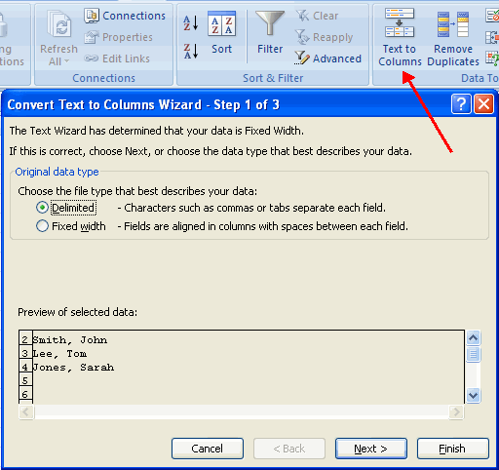

**Modify Fonts**  
Modifying fonts in Excel will allow you to emphasize titles and headings. To modify a font:

* Select the cell or cells that you would like the font applied
* On the **Font** group on the **Home** tab, choose the font type, size, bold, italics, underline, or color

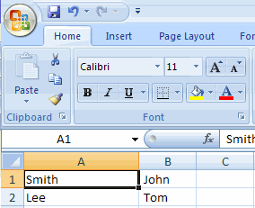

**Format Cells Dialog Box**  
In Excel, you can also apply specific formatting to a cell. To apply formatting to a cell or group of cells:

* Select the cell or cells that will have the formatting
* Click the **Dialog Box** arrow on the **Alignment** group of the **Home** tab

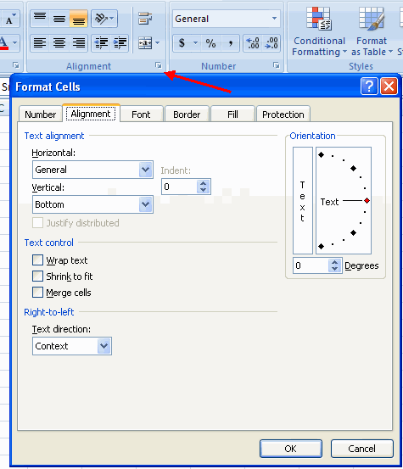

There are several tabs on this dialog box that allow you to modify properties of the cell or cells.

**Number**:  Allows for the display of different number types and decimal places  
**Alignment**:  Allows for the horizontal and vertical alignment of text, wrap text, shrink text, merge cells and the direction of the text.  
**Font**:  Allows for control of font, font style, size, color, and additional features  
**Border**:  Border styles and colors  
**Fill**:  Cell fill colors and styles

**Add Borders and Colors to Cells**  
Borders and colors can be added to cells manually or through the use of styles.  To add borders manually:

* Click the **Borders** drop down menu on the **Font** group of the **Home** tab
* Choose the appropriate border

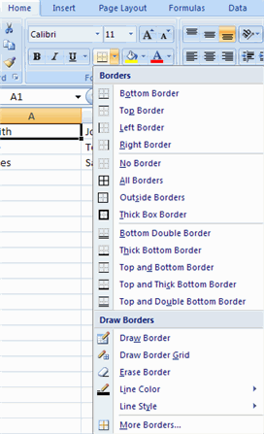

To apply colors manually:

* Click the **Fill** drop down menu on the **Font** group of the **Home** tab
* Choose the appropriate color

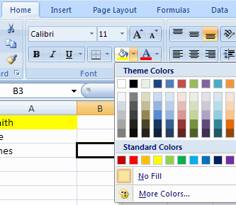

To apply borders and colors using styles:

* Click **Cell** Styles on the **Home** tab
* Choose a style or click **New Cell Style**

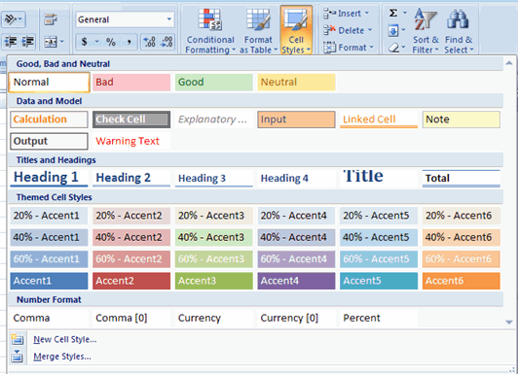

**Change Column Width and Row Height**  
To change the width of a column or the height of a row:

* Click the **Format** button on the **Cells** group of the **Home** tab
* Manually adjust the height and width by clicking **Row Height**or **Column Width**
* To use **AutoFit** click **AutoFit Row Height** or **AutoFit Column Width**

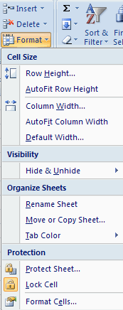

**Hide or Unhide Rows or Columns**  
To hide or unhide rows or columns:

* Select the row or column you wish to hide or unhide
* Click the **Format** button on the **Cells** group of the **Home** tab
* Click **Hide & Unhide**

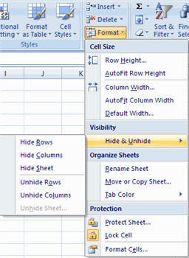

**Merge Cells**  
To merge cells select the cells you want to merge and click the **Merge & Center** button on the **Alignment** group of the **Home** tab.  The four choices for merging cells are:

**Merge & Center**: Combines the cells and centers the contents in the new, larger cell  
**Merge Across**: Combines the cells across columns without centering data  
**Merge Cells**: Combines the cells in a range without centering  
**Unmerge Cells**: Splits the cell that has been merged

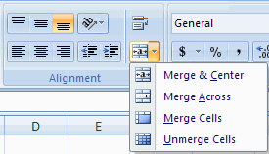

**Align Cell Contents**  
To align cell contents, click the cell or cells you want to align and click on the options within the **Alignment**group on the **Home** tab.  There are several options for alignment of cell contents:

**Top Align**:  Aligns text to the top of the cell  
**Middle Align**:  Aligns text between the top and bottom of the cell  
**Bottom Align**:  Aligns text to the bottom of the cell  
**Align Text Left**:  Aligns text to the left of the cell  
**Center**:  Centers the text from left to right in the cell  
**Align Text Right**:  Aligns text to the right of the cell  
**Decrease Indent**:  Decreases the indent between the left border and the text  
**Increase Indent**:  Increase the indent between the left border and the text  
**Orientation**:  Rotate the text diagonally or vertically

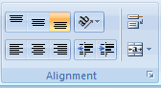

## Developing a Workbook

**Format Worksheet Tab**You can rename a worksheet or change the color of the tabs to meet your needs.  
To rename a worksheet:

* Open the sheet to be renamed
* Click the **Format** button on the **Home** tab
* Click **Rename** sheet
* Type in a new name
* Press **Enter**

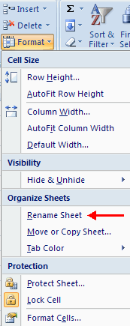

To change the color of a worksheet tab:

* Open the sheet to be renamed
* Click the **Format** button on the **Home** tab
* Click **Tab** Color
* Click the color

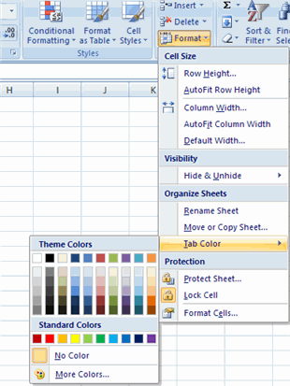

**Reposition Worksheets in a Workbook**  
To move worksheets in a workbook:

* Open the workbook that contains the sheets you want to rearrange
* **Click and hold** the worksheet tab that will be moved until an arrow appears in the left corner of the sheet
* **Drag**the worksheet to the desired location

Move Worksheet

**Insert and Delete Worksheets**  
To insert a worksheet

* Open the workbook
* Click the **Insert** button on the **Cells** group of the **Home** tab
* Click **Insert Sheet**

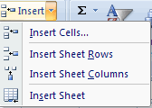

To delete a worksheet

* Open the workbook
* Click the **Delete** button on the **Cells** group of the **Home** tab
* Click **Delete Sheet**

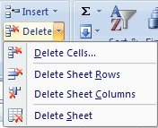

**Copy and Paste Worksheets**:  
To copy and paste a worksheet:

* Click the tab of the worksheet to be copied
* **Right click**and choose **Move** or **Copy**
* Choose the desired position of the sheet
* Click the check box next to **Create a Copy**
* Click **OK**

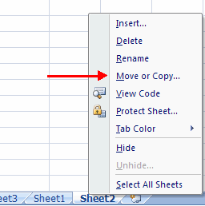

## Page Properties and Printing

**Set Print Titles**  
The print titles function allows you to repeat the column and row headings at the beginning of each new page to make reading a multiple page sheet easier to read when printed.  To Print Titles:

* Click the **Page Layout** tab on the Ribbon
* Click the **Print Titles** button
* In the **Print Titles** section, click the box to select the rows/columns to be repeated
* Select the row or column
* Click the **Select Row/Column Button**
* Click OK

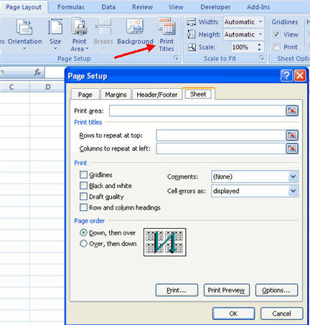

**Create a Header or Footer**  
To create a header or footer:

* Click the **Header & Footer** button on the **Insert** tab
* This will display the **Header & Footer Design Tools Tab**
* To switch between the Header and Footer, click the **Go to Header** or **Go to Footer**button

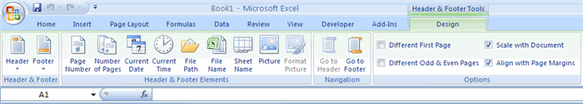

* To insert text, enter the text in the header or footer
* To enter preprogrammed data such as page numbers, date, time, file name or sheet name, click the appropriate button
* To change the location of data, click the desired cell

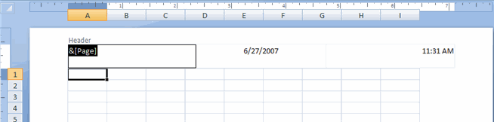

**Set Page Margins**  
To set the page margins:

* Click the **Margins** button on the **Page Layout** tab
* Select one of the give choices, or

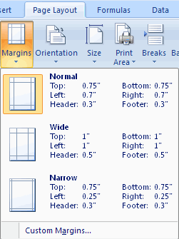

* Click **Custom Margins**
* Complete the boxes to set margins
* Click **Ok**

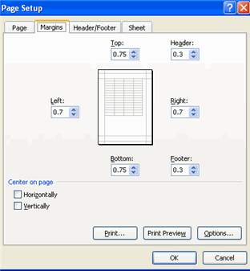

**Change Page Orientation**  
To change the page orientation from portrait to landscape:

* Click the **Orientation** button on the **Page Layout** tab
* Choose **Portrait** or **Landscape**

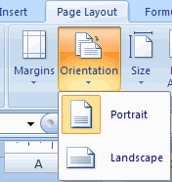

**Set Page Breaks**  
You can manually set up page breaks in a worksheet for ease of reading when the sheet is printed.  To set a page break:

* Click the **Breaks** button on the **Page Layout** tab
* Click **Insert Page Break**

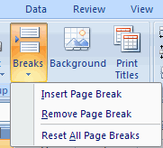

**Print a Range**  
There may be times when you only want to print a portion of a worksheet.  This is easily done through the Print Range function.  To print a range:

* Select the area to be printed
* Click the **Print Area**button on the **Page Layout** tab
* Click **Select Print Area**

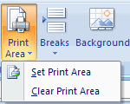

## Layout

**Split a Worksheet**  
You can split a worksheet into multiple resizable panes for easier viewing of parts of a worksheet. To split a worksheet:

* Select any cell in center of the worksheet you want to split
* Click the **Split** button on the **View** tab
* Notice the split in the screen, you can manipulate each part separately

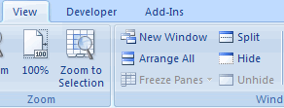

**Freeze Rows and Columns**  
You can select a particular portion of a worksheet to stay static while you work on other parts of the sheet.  This is accomplished through the Freeze Rows and Columns Function.  To Freeze a row or column:

* Click the **Freeze Panes** button on the **View** tab
* Either select a section to be frozen or click the defaults of top row or left column
* To unfreeze, click the **Freeze Panes** button
* Click **Unfreeze**

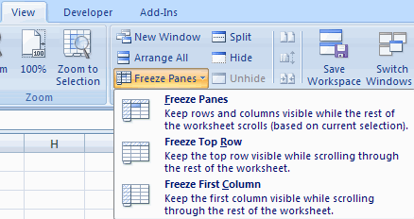

**Hide Worksheets**  
To hide a worksheet:

* Select the tab of the sheet you wish to hide
* **Right-click** on the tab
* Click **Hide**

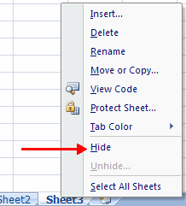

To unhide a worksheet:

* **Right-click** on any worksheet tab
* Click **Unhide**
* Choose the worksheet to unhide

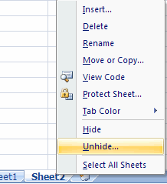

## Customize Excel

Excel 2007 offers a wide range of customizable options that allow you to make Excel work the best for you.  To access these customizable options:

* Click the **Office Button**
* Click **Excel Options**

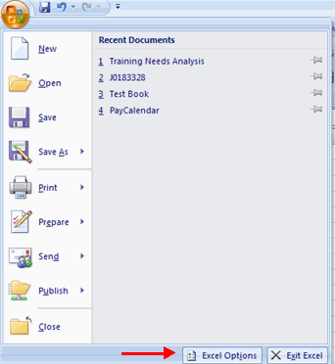

### Popular

These features allow you to personalize your work environment with the mini toolbar, color schemes, default options for new workbooks, customize sort and fill sequences user name and allow you to access the Live Preview feature.  The Live Preview feature allows you to preview the results of applying design and formatting changes without actually applying it.

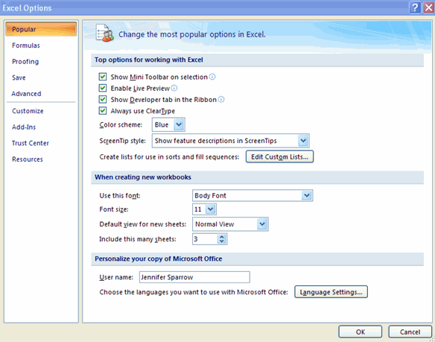

### Formulas

This feature allows you to modify calculation options, working with formulas, error checking, and error checking rules.

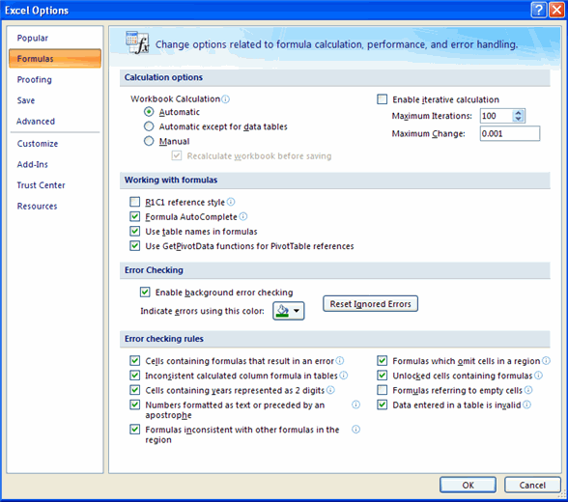

### Proofing

This feature allows you personalize how word corrects and formats your text. You can customize auto correction settings and have word ignore certain words or errors in a document through the Custom Dictionaries.

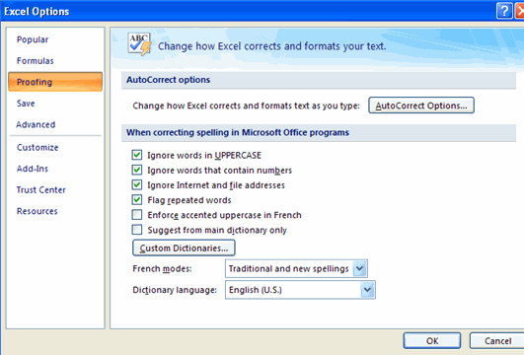

### Save

This feature allows you personalize how your workbook is saved.  You can specify how often you want auto save to run and where you want the workbooks saved.

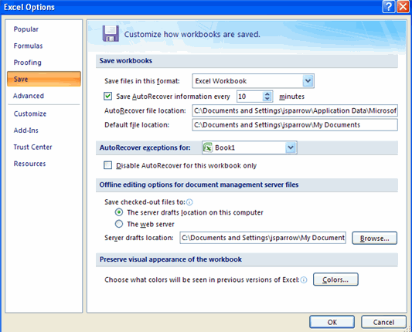

### Advanced

This feature allows you to specify options for editing, copying, pasting, printing, displaying, formulas, calculations, and other general settings.

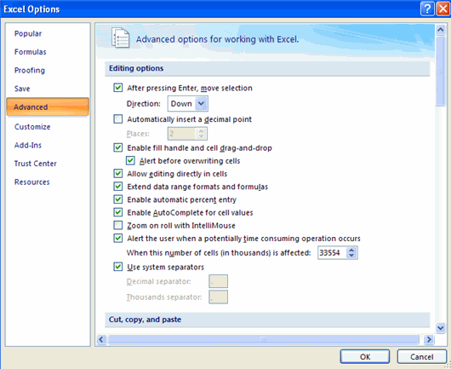

### Customize

Customize allows you to add features to the Quick Access Toolbar.  If there are tools that you are utilizing frequently, you may want to add these to the Quick Access Toolbar.

